climada module tropical cyclone[1] 24 Dec 2015

<https://github.com/davidnbresch/climada_module_tropical_cyclone>

[david.bresch@gmail.com](mailto:david.bresch@gmail.com), [muellele@gmail.com](mailto:muellele@gmail.com)

This module implements the tropical cyclone (TC) attenuation after landfall for probabilistic events. Make yourself familiar with the core climada tropical cyclone hazard event set (and its generation) first. A good implementation of both the basic, probabilistic and advanced tropical cyclone hazard generation can be found in the climada module country risk[2] and there in the routine centroids_generate_hazard_sets.

Since 24 Dec 2015, this module also contains the former modules tc_rain and tc_surge, hence it now also implements tropical cyclone surge (TS) and rain (TR). For the time being, there are still stand-alone manuals for those two sub-perils (in the same folder as the present file). See these for tropical cyclone surge (TS, documentation file named submodule tc_surge) and rain (TR, documentation file named submodule tc_rain).

This module is not to be used stand-alone, but usually such as:

% read TC tracks from database file:

tc_track=climada_tc_read_unisys_database

% wind speed decay at track nodes after landfall:

[~,p_rel] = climada_tc_track_wind_decay_calculate(tc_track,1);

% generate the probabilistic TC tracks:

tc_track=climada_tc_random_walk(tc_track);% overwrites to save memory

% add the inland decay correction to all probabilistic nodes:

tc_track = climada_tc_track_wind_decay(tc_track, p_rel,1);

% plot the tracks

for event_i=1:length(tc_track)

plot(tc_track(event_i).lon,tc_track(event_i).lat,'-b');

end % event_i

% overlay historic (to make them visible, too)

for event_i=1:length(tc_track)

if tc_track(event_i).orig_event_flag

plot(tc_track(event_i).lon,tc_track(event_i).lat,'-r');

end

end % event_i

climada_plot_world_borders(2) % plot world borders

box on; axis equal; axis(centroids_rect);

xlabel('blue: probabilistic, red: historic');

% generate the TC hazard event set:

hazard = climada_tc_hazard_set(tc_track,centroids);

Table of Contents

Historical data 3

Probabilistic data 4

Hazard 7

Visual analysis of historical tracks 15

Generate the Probabilistic Set 16

Analyse Probabilistic Data Set 18

Visual Analysis of Probabilistic Data Set 20

Appendix 21

Structure of the Raw Tropical Cyclone Data Files 23

Generation of Probabilistic Tropical Cyclone Tracks 24

Tropical Cyclone Tracks in the Southwest Indian Ocean 26

Characteristics of Tropical Cyclones from 1978 to 2011 26

Modeling Approach for Wind Speed 27

Generation of Probabilistic Wind Speed 29

The climada tropical cyclone (TC) hazard module forms an integral part of the probabilistic damage model. The hazard module characterizes the peril through the description where, how often and with what intensity events occur. The hazard module can be developed for almost any hazard (wind, flood, storm surge, landslides…). Here, we describe how to generate an **advanced** tropical cyclone hazard.

Tropical cyclones are rapidly rotating storm systems that are characterized by a low-pressure center, strong winds and spiral arrangement of thunderstorms that produce heavy rains. Depending on their location and strength, tropical cyclones are referred differently, such as hurricanes in the western North Atlantic, eastern North Pacific, Caribbean Sea and Gulf of Mexico, typhoons in the western North Pacific, cyclones in the South Pacific, Indian Ocean, the Bay of Bengal and the Arabian Sea. Figure 1 displays historical tropical cyclones worldwide.

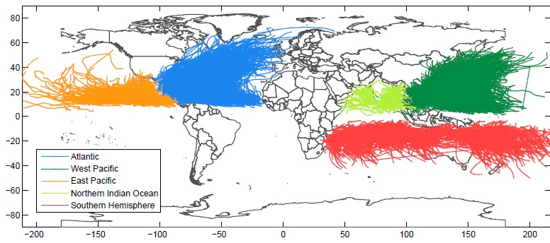

Figure: Historical tropical cyclone tracks in the Atlantic, the West Pacific, East Pacific, Northern Indian Ocean and the Southern Hemisphere.

### Historical data

1a) Download the data

The climada (core) routine **climada_tc_get_unisys_databases** does it all automatically for you.

Download the raw data from [*http://weather.unisys.com/hurricane*](http://weather.unisys.com/hurricane)*.*

Basin Internet page

North Atlantic (atl) <http://weather.unisys.com/hurricane/atlantic/tracks.atl>

East Pacific (epa) <http://weather.unisys.com/hurricane/e_pacific/tracks.epa>

West Pacific (wpa) <http://weather.unisys.com/hurricane/w_pacific/tracks.wpa>

Southern Hemisphere (both Pacific and South Indian Ocean) (she)

<http://weather.unisys.com/hurricane/s_indian/tracks.she>

North Indian Ocean (nio) <http://weather.unisys.com/hurricane/n_indian/tracks.nio>

Upon download, it is worth adding the extension .txt, so the files can be read with any editor (they are ASCII), such that the North Atlantic file becomes e.g. **tracks.atl.txt**. In order of testing routines and understanding the methodology in a faster way, a shortened version of the North Atlantic dataset, **TEST_tracks.atl.txt** is often used, referred to as **TEST atl** data (just comprising the last few years of data). You find this dataset at *…\climada\data\tc_tracks\TEST_tracks.atl.txt*

Please consult Appendix B for details of the raw data file structure.

1b) Add storm category

Add storm category according to Saffir - Simpson Hurricane Scale to every track (Table 1).

**tc_track =climada_tc_stormcategory(tc_track);**

*Table 1: Saffir-Simpson Hurricane Scale.*

*Category Maximum Sustained Wind Speed* Storm Surge*

*knots mph km/h m/s m*

|  |  |  |  |  |  |
| --- | --- | --- | --- | --- | --- |
| Tropical Depression | < 34 | < 39 | < 63 | < 18 | ≈ 0 |
| Tropical Storm | < 64 | < 73 | < 118 | < 33 | 0,1–1,1 |
| Hurrican Category 1 | < 83 | < 95 | < 153 | < 43 | 1,2–1,6 |
| Hurrican Category 2 | < 96 | <110 | < 177 | < 49 | 1,7–2,5 |
| Hurrican Category 3 | < 113 | <130 | < 209 | < 58 | 2,6–3,8 |
| Hurrican Category 4 | < 135 | <155 | < 249 | < 69 | 3,9–5,5 |
| Hurrican Category 5 | > 135 | > 155 | > 250 | > 70 | > 5,5 |

* 1-minute period, at 10 m (33 ft) above the surface

Source: [*http://en.wikipedia.org/wiki/Saffir%E2%80%93Simpson_Hurricane_Scale*](http://en.wikipedia.org/wiki/Saffir%E2%80%93Simpson_Hurricane_Scale)

### Probabilistic data

2a) Incorporate wind speed decay after landfall

In order to have realistic probabilistic tracks, a wind speed decay function needs to be incorporated. The wind speed decay function can be derived from the historical tc tracks. We use an exponential decay function as proxy for the wind speed decay. The exponential decay function is calculated with the function **climada_tc_track_wind_decay_calculate** y and the parameters are saved in the file **p_rel.mat**. For more information on wind decay after landfall see Appendix 6a).

Firstly we need to identify the timing of landfalls to each tc_track structure and hence we add an on land variable for every TC track. Hint: see **border_mask** (matlab variable) to understand land/sea differentiation.

**tc_track =climada_tc_track_on_land(tc_track,border_mask)**

Secondly, we calculate the wind speed decay after landfall based on historical tc tracks:

[tc_track p_rel]=...  
climada_tc_track_wind_decay_calculate(tc_track,check_plot);

And thirdly, we apply the wind speed decay function to the probabilistic tracks

**tc_track_prob=...  
climada_tc_track_wind_decay(tc_track_prob,p_rel, check_plot);**

Finally add the saffir simpson storm category to each tc track based on the maximum sustained wind speed over the track lifetime.

**tc_track = climada_tc_stormcategory (tc_track);**

Absolute wind speed decay Relative wind speed decay

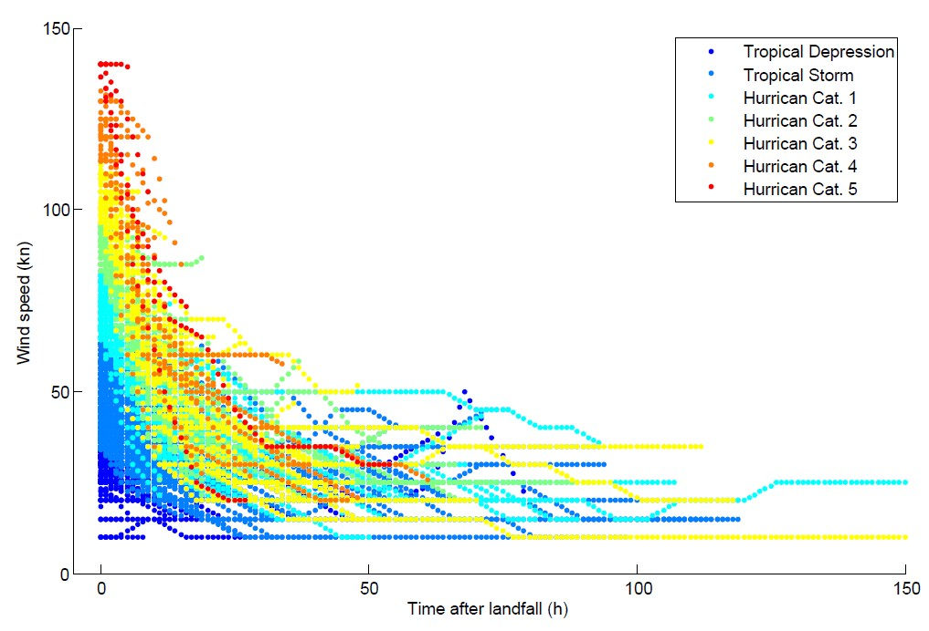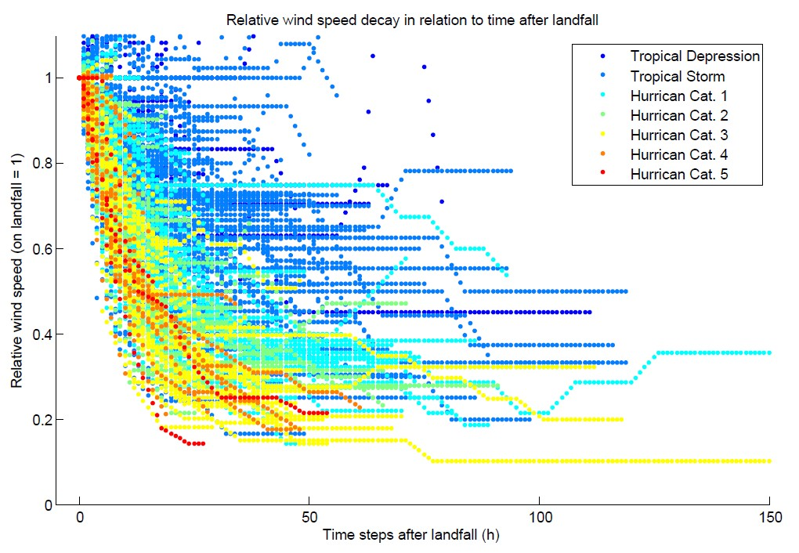

*Figure 2: Absolute wind speed decay after landfall of historical tracks in the North Atlantic (1445 tracks).*

*Figure 3: Relative wind speed decay after landfall of historical tracks in the North Atlantic (1445 tracks). Wind at landfall equals 1.*

Relative wind speed decay with fitted functions Fitted functions of wind speed decay

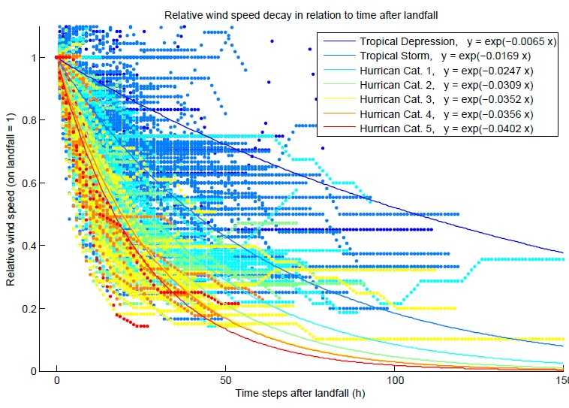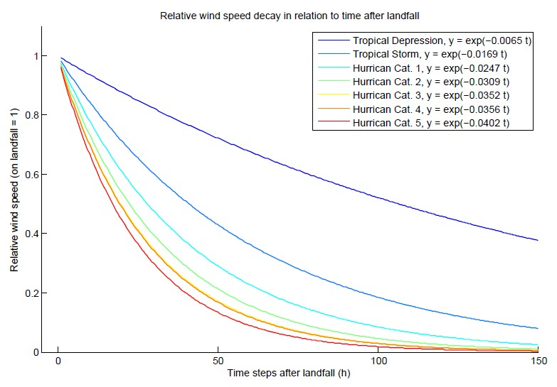

*Figure 4: Relative wind speed decay after landfall of historical tracks in the North Atlantic (1445 tracks). Wind at landfall equals 1. The lines are the fitted functions for the exponential decay with starting point 1 at landfall.*

*Figure 5; Relative wind decay, fitted functions for tropical depression, storm and Hurricanes category 1 to 5.*

### Hazard

3a) Calculate distance to coast for centroids

Calculate distance to closest coastline for every centroid. The basis for this calculation is the coastline data. The coastline data is downloaded from NOAA[3] and saved in *…\climada_module_tc_hazard_adavanced\data\coastline.txt*

**coastline=climada_coastline_read(centroids,coastline_file, check_plot)**

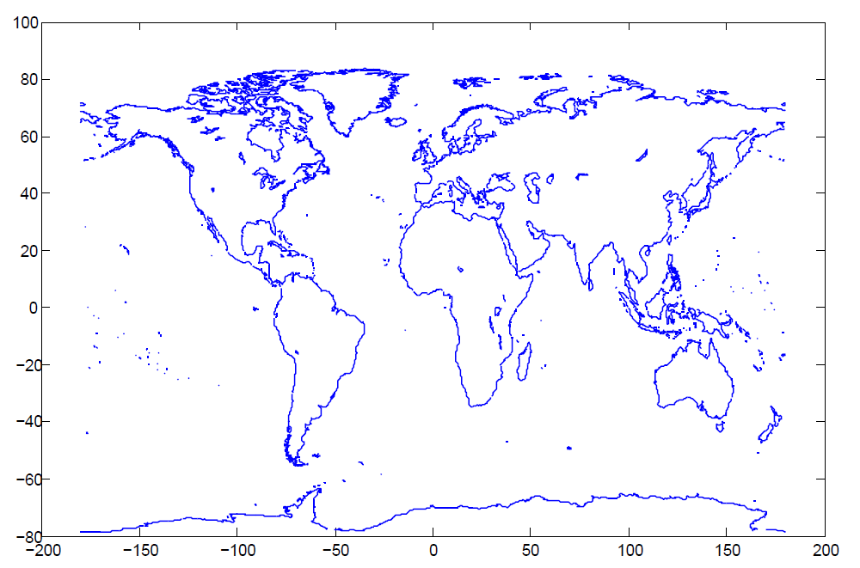*Figure 6: Coast line downloaded from* 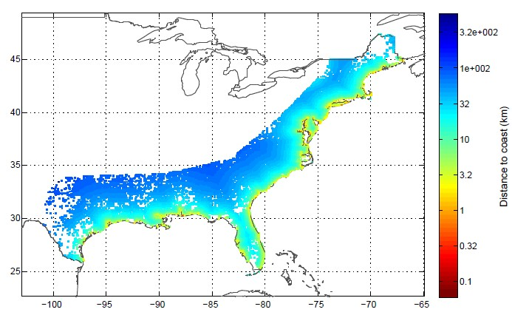

*Figure 7: Distance to coast for every centroid in km and* *displayed with a logarithmic color scheme.*

centroids=...

climada_centroids_distance_to_coast(centroids,coastline,check_figure)

3b) Generate the wind footprint(s)

Generate wind field resulting from single track of tropical cyclone. The function converts **tc_track.MaxSustainedWind** in knots to **res.gust** in m/s.

Normally the wind footprint calculation is tested on a single TC track prior to generation of the hazard event set of all the entire historical and probabilistic track set. The TC windfield calculations are speeded up by only calculating for centroids within 750 km distance of min,max track lon/lat and by not assigning **res.node_lon(centroid_i)**, **res.node_lat(centroid_i).** Uses function **climada_gridded_VALUE**

**res = climada_tc_windfield(tc_track,centroids,equal_timestep,   
 silent_mode, check_plot)**

Method: Currently, the code implements the Holland windfield[4]

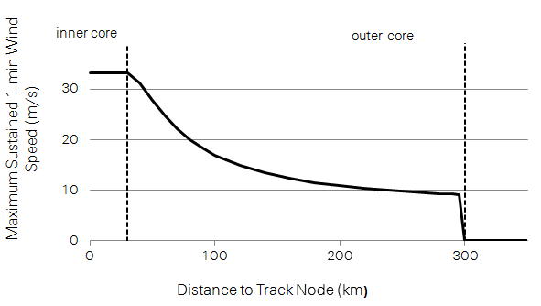

*Figure: Maximum sustained 1 min wind speed in relation to the distance to the track node.*

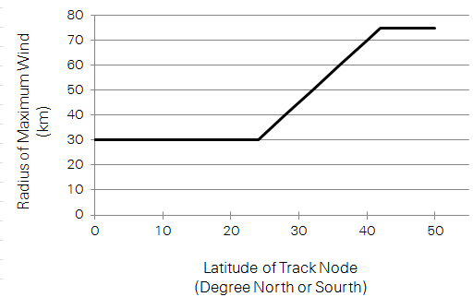

*Figure: Radius of maximum wind in relation to latitude of track node.*

Finally the wind speed (S) describes the maximum sustained 1 min wind speed. To get wind gusts that a few seconds (3..5 s) wind peaks are typically around 27% higher than a 1 min sustained wind in a hurricane environment[5].

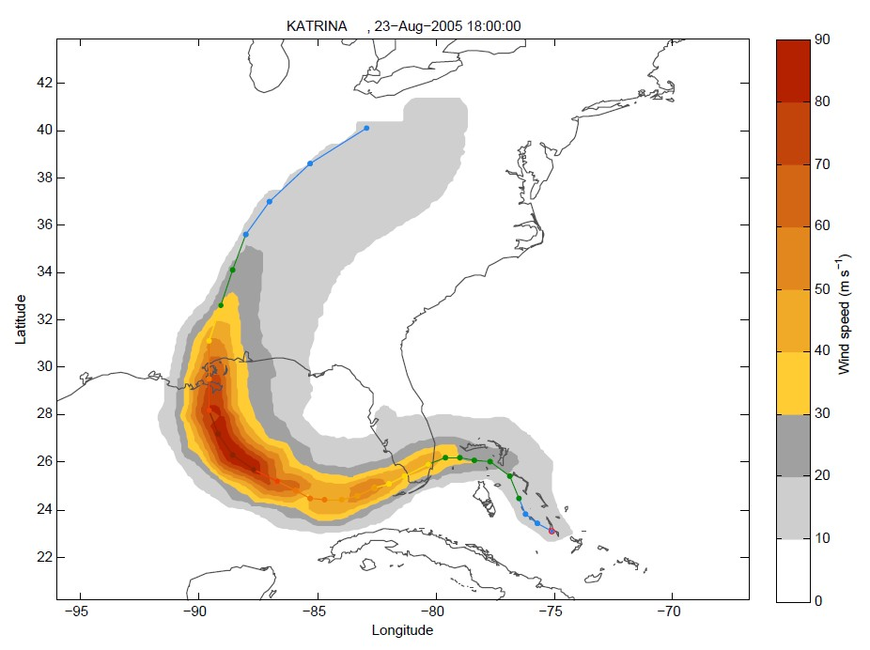

Figure: Wind footprint calculated based on track 1340 Katrina.

Any other windfield parametrization can be implemented in a similar fashion (just implement in a copy of climada_tc_windfield, e.g. **climada_tc_windfield2**, see also the routine **climada_tc_hazard_set** to change the caller when generating the probabilistic set).

In order to test the wind field calculation, the following might help:

Use the tc_track structure (should still be in memory), but start with only one track, e.g. tc_track(84) for the 84th track. Investigate tc_track.name to find a particular event. Use e.g. the following code to show a list of track number, year and name:

for i=1:length(tc_track)

fprintf('%i %i %s\n',i,tc_track(i).yyyy(1),...  
char(tc_track(i).name));

end

Load the centroids using **centroids = climada_centroids_read('',1)**, note that this call also plots the centroids (use the zoom function on the map). See also the parameter **check_plot** in the PARAMETER section of the code or refer to the routine **climada_color_plot**.

3c) Calculate the wind fields for a single track and display as animation

Refines tc track to 1hour resolution, calculates wind field for every time step of 1h. The function displays the wind fields for selected aggregated time steps, e.g. 3h, 6h, 24h. Aggregation default is 6h.

climada_tc_windfield_animation(tc_track(1340),centroids,   
 aggregation, check_avi)

res=climada_tc_windfield_timestep(tc_track(1340),centroids,   
 equal_timestep);

Uses functions **climada_gridded_VALUE** and **climada_tc_windfield_timestep.**

Movie saved in *...\results\windfield_animation_trackname_24h.avi*

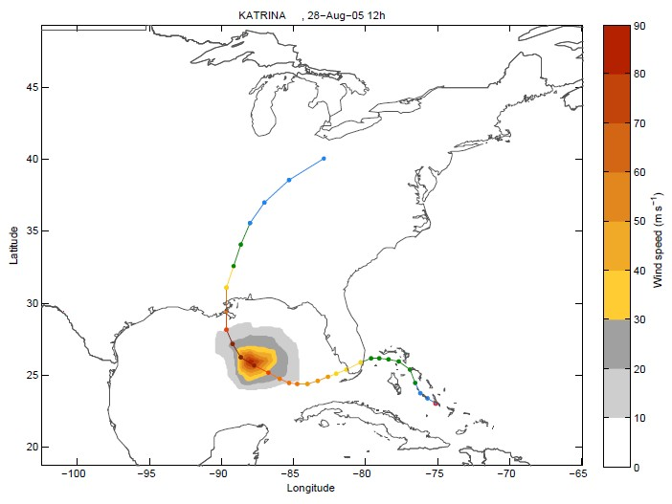

Figure: Wind field calculated for every timestep.

3d) Create the Hazard Set (i.e. all Footprints)

**hazard=climada_tc_hazard_set (tc_track,hazard_set_file,centroids**

3e) Hazard weakening due to distance to coast

A correction for wind speed decrease is introduced in the **hazard.arr** array in order to incorporate the weakening of tropical cyclone when over land. The hazard weakening function depends on the distance to coast as well on the category of the tropical cyclone.

**hazard=...  
 climada_hazard_distance_to_coast (hazard,centroids,tc_track)**

The weakening of the tropical cyclone is assumed with an exponential decay as a function of the distance D from the centroid to the coast (in km). a and b are parameters that vary depending on the cyclone intensity (Saffir-Simpson Scale). The values for the parameters a, b and c for different countries are listed in Table 1.

*Table 1: Parameters for cyclone weakening function depending on cyclone category and country.*

|  |  |  |  |
| --- | --- | --- | --- |
| *USA* |  | | |
| Cyclone category | a | b | c |
| Tropical depression, storm | 0.90 | 700 | 0.90 |
| H. cat 1 and 2 | 0.85 | 500 | 0.85 |
| H. cat 3, 4, and 5 | 0.85 | 320 | 0.35 |
| *Australia*  Tropical depression, storm | 1 | 700 | 0.9 |
| H. cat 1 and 2 | 1 | 25 | 0.5 |
| H. cat 3, 4, and 5 | 1 | 10.5 | 0.2 |
| *Japan*  Tropical depression, storm | 1 | 700 | 0.9 |
| H. cat 1 and 2 | 1 | 25 | 0.5 |
| H. cat 3, 4, and 5 | 1 | 10.5 | 0.2 |
| China  Tropical depression, storm | 1 | 50 | 0.1 |
| H. cat 1 and 2 | 1 | 15 | 0.1 |
| H. cat 3, 4, and 5 | 1 | 8.5 | 0.1 |

For more information on the calibration see Appendix 6.2 Calibration of hazard weakening 6b.

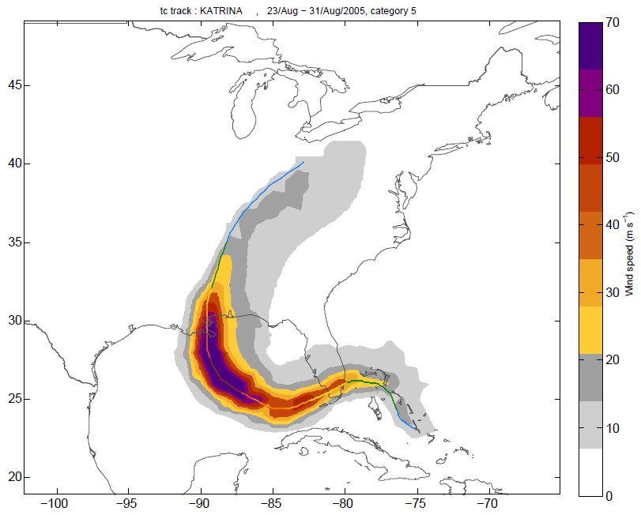

Figure: Unweakened hazard on the example of the footprint of Hurricane Katrina.

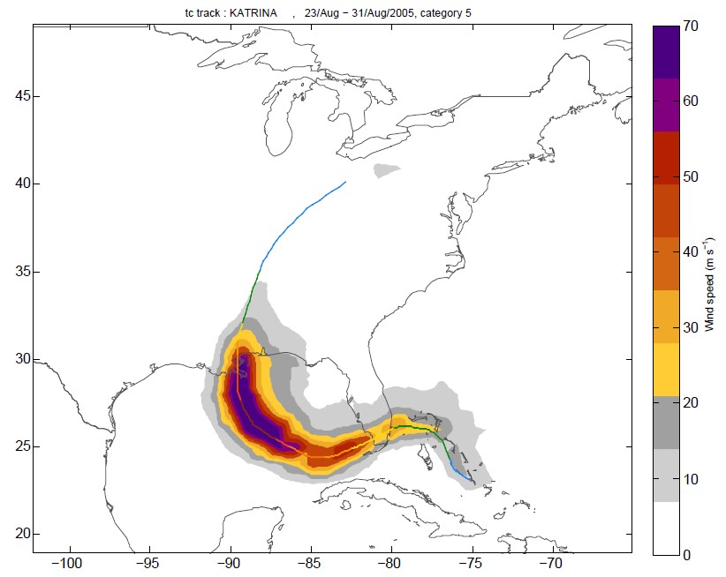

Figure: Weakened hazard on the example of the footprint of Hurricane Katrina.

3f) Create a climate change hazard set

The future hazard set is based on a climate change scenario and today’s hazard set. The intensity or frequency of storms, or particular categories of storms, can be changed accordingly to a specific climate change scenario, by the input structure *screw*. The default values for screw are the climate change projections from IPCC special report on weather extremes (SREX, March 2012[6]) with the given time horizon of 2100, see Table 2. The time

horizon can be set for any given year between today and 2100 and the climate change projections are linearly interpolated.

*Table 2: Default values for screw. The climate change scenario is based on the IPCC SREX*

screw(1) .variable_to_change ‘frequency’

.frequency 0.8

.time_horizon 2100

crew.cat [4 5]

screw(2) .variable_to_change ‘frequency’

.frequency -­‐0.28

.time_horizon 2100

.cat [0 1 2 3]

screw(3) .variable_to_change 'intensity'

.frequency 0.11

.time_horizon 2100

.cat [ 0 1 2 3 4 5]

**hazard=climada_hazard_clim_scen(hazard,tc_track,  
 hazard_save_name,reference_year,screw)**

3g) Analyze Statistics; Plot Wind Speed for Specific Return Periods at all Centroids for Historical Data Set, Probabilistic Data Set or Climate Change Scenario

Plot wind speed based historical, probabilistic or climate change data, for requested return periods at all centroids. If no return periods are specified, it takes return periods indicated in **climada_global.LFC_return_periods**.

hazard=climada_hazard_stats(hazard,return_periods,   
 hazard_R_file,check_plot,centroids,rain,check_printplot)

Probabilistic w ind speed (m/s)

0 50 100



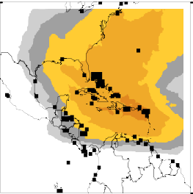25 yr intensity 50 yr intensity

100 yr intensity

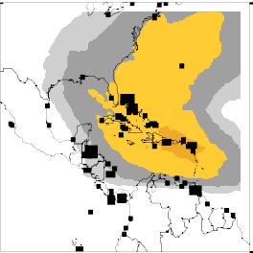

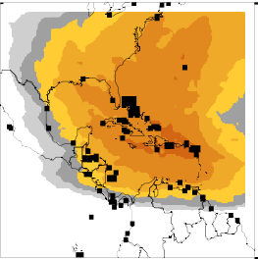200 yr intensity 500 yr intensity 1000 yr intensity

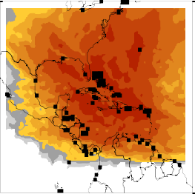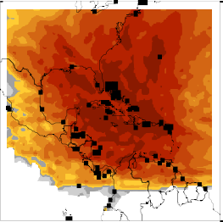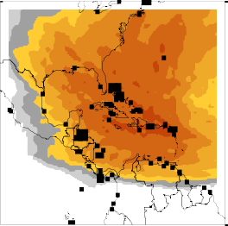

Figure: Wind speed maps for specific return periods.

### Visual analysis of historical tracks

climada_plot_tc_track_stormcategory: Plot single TC track with colour coding according to Saffir-Simpson category.

climada_plot_tc_track_season: Plot all TC tracks during one specific season (year)



Figure: TC tracks recorded in the year 2000 displayed with colours according to the Saffir-Simpson Hurricane Scale. See climada_plot_tc_track_stormcategory and climada_plot_tc_track_season



Figure: All historical storms in the south westerns Indian Ocean from 1978 to 2011. See climada_plot_tc_track_season

climada_distribution_v0_vi: Analyse Distribution of Initial Wind Speed and Change in Wind Speed. In order to subsequently generate the hazard set consisting of probabilistic TC tracks, we consider the distribution of the historical wind speed data. To both the initial wind speed and the changes in wind speed, this function fits a Gaussian distribution and returns its defining mu and sigma, either in knots or in m/s. These parameters then form the basis for generating the probabilistic tracks. The figure is always displayed in m/s, and can be saved in results folder.



Figure: Distribution of initial wind speed v0 (top) and difference in wind speed vi (bottom) for the tracks recorded in the south western Indian Ocean during 1978 and 2011. See climada_distribution_v0_vi

### Generate the Probabilistic Set

climada_tc_random_walk_position_windspeed: In order to generate the probabilistic set, each historical (original) track is varied, using a directed random walk process. In addition to core climada0s climada_tc_random_walk, wind speed is varied in addition to track position (longitude,l atitude).



Figure: Graphical check for climada_tc_random_walk_position_windspeed for TEST atl with default parameters. See climada_tc_random_walk_position_windspeed

### Analyse Probabilistic Data Set

climada_plot_ACE: The function plots histograms of accumulated cyclone energy ACE, No. of storms per seasons, No. of hurricanes and No. of major hurricanes per season of probabilistic tracks, with historical tracks indicated with dotted black lines



Figure: Histograms of available cyclone energy (ACE) (top left), number of tropical storms per season (top right), number of hurricanes per season (bottom left) and number of major hurricanes per season (bottom right). The histograms are based on 4480 probabilistic tracks. The dotted lines indicate the histograms based on the historical tracks. See climada_plot_ACE

climada_distribution_lon_lat: The function plots histograms of start point of longitude and latitude and difference in longitude and latitude of probabilistic tracks, with historical tracks indicated with dotted black lines



Figure: Histograms of starting points of longitude (top left) and latitude (bottom left) and difference in longitude (top right) and latitude (bottom right). The histograms are based on 4480 probabilistic tracks. The dotted lines indicate the histograms based on the historical tracks. See climada_distribution_lon_lat



Figure: Starting points of probabilistic (bottom) and historical tracks (top). See climada_distribution_lon_lat

### Visual Analysis of Probabilistic Data Set

climada_plot_probabilistic_wind_speed_map: Plot one historical tc track (Longitude, Latitude) in world map, colour coded according to Saffir-Simpson Hurricane Scale. Add plot of probabilistic generated sister storms. Historical track has black lines around markers to identify as original track.



Figure: Visual check for historical track 61 and its 9 generated probabilistic storms. See climada_plot_probabilistic_wind_speed_map

climada_plot_probabilistic_wind_speed_lon_lat: Plot historical tc track (wind speed, longitude, latitude) and add wind speed, longitude and latitude of probabilistic generated sister storms. Historical tracks are red, probabilistic blue.



Figure: see climada_plot_probabilistic_wind_speed_lon_lat

### Appendix

#### Background on hurricane wind speed decay after landfall

NOAA, Hurricane Research Division[7]

The sustained (1 min or longer average) winds are reduced because of the dampening effect of larger roughness over land (i.e. bushes, trees and houses over land versus a relatively smooth ocean). The gusts are stronger because turbulence increases and acts to bring faster winds down to the surface in short (a few seconds) bursts.

After just a few hours, a tropical cyclone over land will begin to weaken rapidly -­‐ not because of friction -­‐ but because the storm lacks the moisture and heat sources that the ocean provided. This depletion of moisture and heat hurts the tropical cyclone's ability to produce thunderstorms near the storm centre. Without this convection, the storm rapidly fills.

Nature conducted this experiment during Andrew as the hurricane traversed the very wet Everglades, Big Cypress and Corkscrew Swamp areas of southwest Florida. Andrew weakened dramatically: peak winds **decreased about 33%** and the sea level pressure in the eye rose 19 mb[8].

Hurricane Science, University of Rhode Island (URI), Graduate School of Oceanography (GSO)[9]

Landfall usually causes a hurricane to quickly decay. Hurricanes require evaporation from the warm ocean surface to survive. Once a hurricane makes landfall, it is separated from its ocean energy source, and hence, can no longer extract heat from the ocean. Since the air masses over land are drier and contain more aerosol particles than over the ocean, less moisture is carried into the storm, cloud coverage lessens, and air is cooled and then sinks, disrupting the hurricane’s secondary circulation and hindering critical thunderstorm development. To a lesser extent, the increased roughness of the land surface also weakens a hurricane as increased friction causes a reduction in surface circulation.

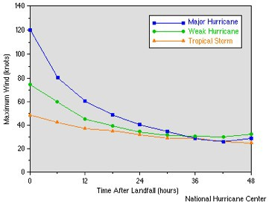

Figure 13: This graph shows how rapidly wind speed decreases once a hurricane reaches land. The roughness of the land terrain increases friction, but more critical, once over land, the system is cut off from its heat and moisture sources. Sustained winds in a hurricane will decrease at a relatively constant rate (approximately half the wind speed in the first 24 hours). Thus, the faster the forward speed of a landfalling hurricane, the further inland hurricane force winds may penetrate. Image credit the National Hurricane Center (NHC).

#### Calibration of hazard weakening

USA

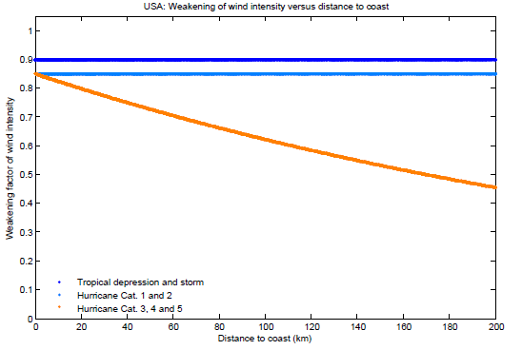

*Figure 14: Hazard wind weakening depending on distance to coast and cyclone category for USA.*

Australia

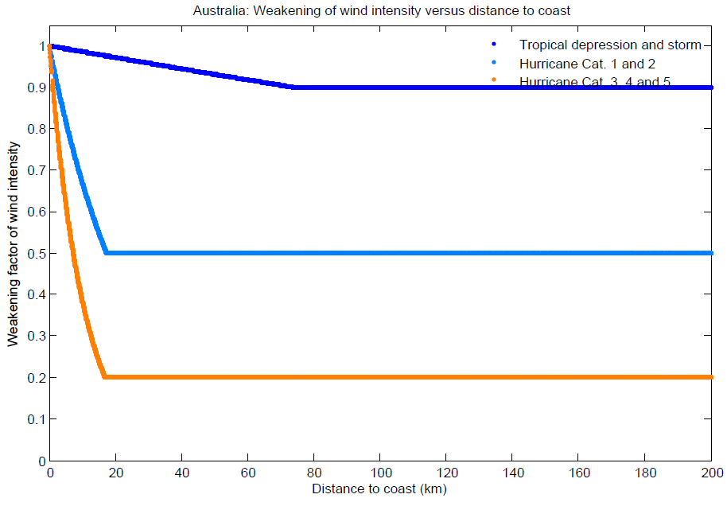

*Figure 15: Wind weakening for Australia*

China

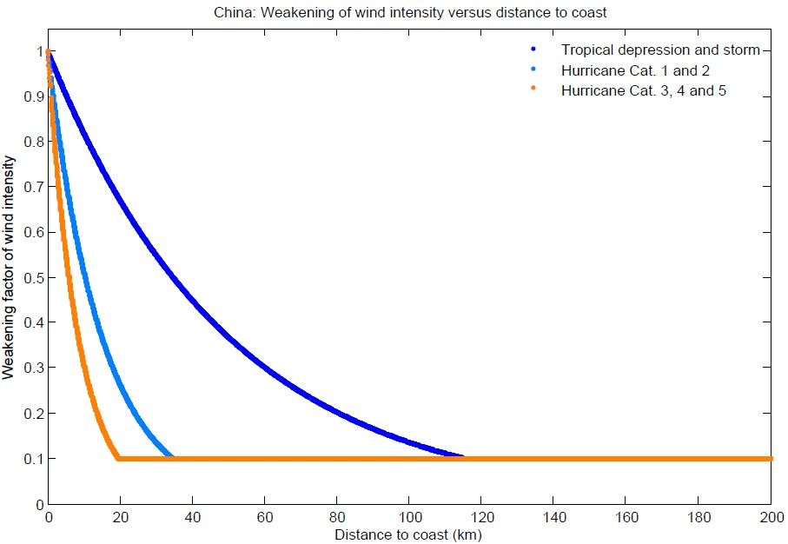

*Figure 16: Wind weakening for China.*

Japan

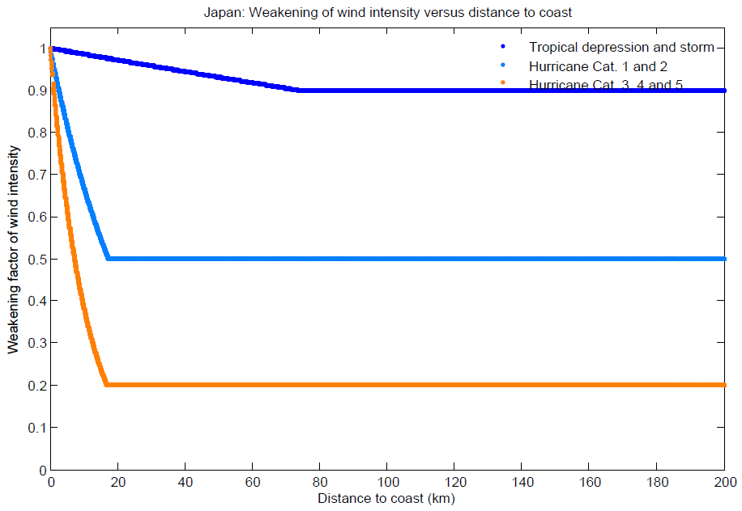

*Figure 17: Wind weakening for Japan*

### Structure of the Raw Tropical Cyclone Data Files

See the function climada_tc_read_unisys_database to read raw tropical cyclone data files. There are three basic types of datalines in the Best Track.

TYPE A:

92620 08/16/1992 M=13 2 SNBR= 899 ANDREW XING=1 SSS=4

Card# MM/DD/Year Days S# Total#... Name........US Hit.Hi US category

TYPE B:

92580 04/22S2450610 30 1003S2490615 45 1002S2520620 45 1002S2550624 45 1003*

Card# MM/DD&LatLongWindPress&LatLongWindPress&LatLongWindPress&LatLongWindPress

TYPE C:

92760 HRCFL4BFL3 LA3

Card# TpHit.Hit.Hit.

TYPE A:

Card# = Sequential card number starting at 00010 in 1886

MM/DD/Year = Month, Day, and Year of storm

Days = Number of days in which positions are available (note that this

also means number of lines to follow of type B and then one line

of type C)

S# = Storm number for that particular year (including subtropical storms)

Total# = Storm number since the beginning of the record (since 1886)

Name = Storms only given official names since 1950

US Hit = '1' = Made landfall over the United States as tropical

storm or hurricane,

'0' = did not make U.S. landfall

Hi US category = '9' = Used before 1899 to indicate U.S. landfall as a

hurricane of unspecified Saffir-Simpson category

'0' = Used to indicate U.S. landfall as tropical storm,

but this has not been utilized in recent years

'1' to '5' = Highest category on the Saffir-Simpson scale

that the storm made landfall along the U.S.

'1' is a minimal hurricane, '5' is a

catastrophic hurricane

TYPE B:

Card# = As above.

MM/DD = Month and Day of Storm

& = 'S' (Subtropical stage), '*' (tropical cyclone stage),

'E' (extratropical stage), 'W' (wave stage - rarely used)

LatLong = Position of storm: 24.5N, 61.0W

Wind = Maximum sustained (1 minute) surface (10m) windspeed in knots (in

general, these are to the nearest 5 knots).

Press = Central surface pressure of storm in mb (if available). Since

1979, central pressures are given everytime even if a satellite

estimation is needed.

Positions and intensities are at 00Z, 06Z, 12Z, 18Z

TYPE C:

Card# = As above.

Tp = Maximum intensity of storm ('HR' = hurricane, 'TS' = tropical

storm, 'SS' = subtropical storm)

Hit = U.S. landfallings as hurricane ('LA' = Louisiana, etc.) and

Saffir-Simpson category at landfall ('1' = minimal hurricane...

'5' = super hurricane). (Note that Florida and Texas are split

into smaller regions: 'AFL' = Northwest Florida, 'BFL' =

Southwest Florida, 'CFL' = Southeast Florida, 'DFL' = Northeast

Florida, 'ATX' = South Texas, 'BTX' = Central Texas, 'CTX' =

North Texas.)

### Generation of Probabilistic Tropical Cyclone Tracks

#### Theoretical Background

#### Total number of tropical storms

http://www.metoffice.gov.uk/weather/tropicalcyclone/northatlantic.html

The number of tropical storms observed over the season is the best known measure of the level of storm activity. However, the total number of storms tells us little about variations in the intensity and lifetime of storms from one season to the next.

#### Accumulated cyclone energy (ACE)

http://en.wikipedia.org/wiki/Accumulated_cyclone_energy

This is a measure of the collective intensity and duration of all tropical storms over the season and thus reflects storm lifetimes and intensities as well as total numbers over the season.

Accumulated cyclone energy (ACE) is a measure used by the National Oceanic and Atmospheric Administration (NOAA) to express the activity of individual tropical cyclones and entire tropical cyclone seasons, particularly the North Atlantic hurricane season. It uses an approximation of the energy used by a tropical system over its lifetime and is calculated every six-hour period. The ACE of a season is the sum of the ACEs for each storm and takes into account the number, strength, and duration of all the tropical storms in the season.[1]

The ACE of a season is calculated by summing the squares of the estimated maximum sustained velocity of every active tropical storm (wind speed 35 knots (65 km/h) or higher), at six-hour intervals. If any storms of a season happen to cross years, the storm's ACE counts for the previous year.[2] The numbers are usually divided by 10,000 to make them more manageable. The unit of ACE is 104 kt2, and for use as an index the unit is assumed. Thus:



where vmax is estimated sustained wind speed in knots.

Kinetic energy is proportional to the square of velocity, and by adding together the energy per some interval of time, the accumulated energy is found. As the duration of a storm increases, more values are summed and the ACE also increases such that longer-duration storms may accumulate a larger ACE than more-powerful storms of lesser duration. Although ACE is a value proportional to the energy of the system, it is not a direct calculation of energy (the mass of the moved air and therefore the size of the storm would show up in a real energy calculation).

A related quantity is hurricane destruction potential (HDP), which is ACE but only calculated for the time where the system is a hurricane.[1]

A season's ACE is used to categorize the hurricane season by its activity. Measured over the period 1951–2000 for the Atlantic basin, the median annual index was 87.5 and the mean annual index was 93.2. The NOAA categorisation system[3] divides seasons into:

Above-normal season: An ACE value above 103 (117% of the 1951–2000 median), provided at least two of the following three parameters exceed the long-term average: number of tropical storms (10), hurricanes (6), and major hurricanes (2).

Near-normal season: neither above-normal nor below normal

Below-normal season: An ACE value below 66 (75% of the 1951–2000 median)

Atlantic hurricane seasons by ACE index, 1950–2010

The term hyperactive is used by Goldenberg et al. (2001) [4] based on a different weighting algorithm[5] which places more weight on major hurricanes, but typically equating to an ACE of about 153 (171% of the current median). For the in progress season be advised that the ACE is preliminary based on NHC bulletins, which may later be revised.

|  |  |  |  |  |  |
| --- | --- | --- | --- | --- | --- |
| Season | ACE | TS | HR | MH | Classification |
| 2005 Atlantic hurricane season | 248 | 28 | 15 | 7 | Above normal (hyperactive) |
| 1950 Atlantic hurricane season | 243 | 13 | 11 | 8 | Above normal (hyperactive) |
| 1995 Atlantic hurricane season | 228 | 19 | 11 | 5 | Above normal (hyperactive) |
| 2004 Atlantic hurricane season | 225 | 15 | 9 | 6 | Above normal (hyperactive) |
| 1961 Atlantic hurricane season | 205 | 11 | 8 | 7 | Above normal (hyperactive) |
| 1955 Atlantic hurricane season | 199 | 12 | 9 | 6 | Above normal (hyperactive) |

Key

* ACE Accumulated cyclone energy
* TS Number of tropical storms (including subtropicals)
* HR Number of hurricanes (S-S Category 1 – 5)
* MH Number of major hurricanes (Category 3 – 5)

#### Maximum intensity theory

Kerry Emanuel, 1988: The Maximum Intensity of Hurricanes

<ftp://texmex.mit.edu/pub/emanuel/PAPERS/max88.pdf>

DeMaria and Kaplan, 1993: Sea Surface Temperature and the Maximum Intensity of Atlantic Tropical Cyclones.

<http://studentresearch.wcp.muohio.edu/HurricanesPhyBiolEffects/articles/SST.MI.atlantic.pdf>

### Tropical Cyclone Tracks in the Southwest Indian Ocean

Information on historical tropical cyclones is available from Unisys Weather Homepage (http://weather.unisys.com/hurricane/index.php) that was recorded by the Joint Typhoon Warning Center (JTWC). It provides position in latitude and longitude, maximum sustained winds and central pressure.

Following World Meteorological Organization (WMO) guidelines, most regions use a 10-minute average. However, the Joint Typhoon Warning Center (JTWC), Guam, and WMO Region IV (United States and Caribbean area) use a 1-minute standard average. However, the Saffir-Simpson Hurricane Scale is based on wind speed measurements averaged over a 1-minute period, at 10 m (33 ft) above the surface

(http://en.wikipedia.org/wiki/Tropical_cyclone_scales).

As a rule of thumb the factor 0.88 is used in going from a 1-minute system to a 10-minute system such that (http://www.nrlmry.navy.mil/~chu/chap6/se200.htm):

TEN-MINUTE MEAN = 0.88 * ONE-MINUTE MEAN or

ONE-MINUTE MEAN = 1.14 * TEN-MINUTE MEAN

Data is available from January 1978 to March 2011. Multiple tropical cyclone tracks are occasionally linked together due to the date line (Figure 32) and need to be separated. For the further analysis only tropical cyclone tracks in the southwestern Indian Ocean are taken into account.

448 tracks are recorded to have occurred in the south western Indian Ocean. Tropical cyclone tracks for the period of record are displayed in Figure below.



Figure: Tropical cyclone tracks in the year 1983 with colour coding based on the Saffir-Simpson Hurricane Scale. Tracks can be linked together due to the date line and need to be separated for the further analysis.

### Characteristics of Tropical Cyclones from 1978 to 2011

The tropical cyclones in the south western Indian ocean from 1978 to 2011 can be characterized by available cyclone energy (ACE), number of tropical storms, hurricanes and major hurricanes per season.

Figure below show the above mentioned characteristics and the histograms based on all the tracks recorded in the south western Indian Ocean and based on the 161 tracks recorded with a longitude smaller than 60°, respectively.



Figure: Available cyclone energy (ACE) during the cyclone seasons from 1978 to 2011 (top) and number of tropical storms, hurricanes and major hurricanes for the same seasons, based on all 448 tracks recorded in the south western Indian Ocean.



Figure: Histograms of available cyclone energy (ACE) (top left), number of tropical storms per season (top right), number of hurricanes per season (bottom left) and number of major hurricanes per season (bottom right). The histograms are based on all 448 tracks recorded in the south western Indian Ocean.

### 

### Modeling Approach for Wind Speed

Wind speed is the sum of an initial wind speed v0 and independent and identically distributed changes in wind speed vi (<http://www.mathematik.uni-ulm.de/stochastik/aktuelles/sh06/sh_rumpf.pdf> , 15 June 2011). Figure below shows the distribution of initial wind speed v0 and difference in wind speed vi for all the tracks recorded in the south western Indian Ocean.



Figure: Distribution of initial wind speed v0 (top) and difference in wind speed vi (bottom) for the tracks recorded in the south western Indian Ocean during 1978 and 2011.

Normal distribution

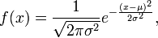



Mean μ = − b / 2a

Variance σ2 = − 1 / 2a

one must choose c such that 

### Generation of Probabilistic Wind Speed

Plot distribution of initial wind speed and change in wind speed from historical tracks. Fit a normal distribution to each and display according mu and sigma of initial wind speed and change in wind speed.

Generate probabilistic change in wind speed for every node by using mu and sigma from the historical data set.

Vi = mu(2) + sigma(2) .* randn(ens_size,nodes_count);

Add up probabilistic changes in wind speed.

vi_cum = cumsum(vi(ens_i,:));

Sum up initial wind speed and following changes in wind speed.

V = tc_track(track_i).MaxSustainedWind + vi_cum;

Round to 5 kn.

v = round(v/5)*5;

Figure below shows the histograms based on the probabilistic wind speed (bars) and based on the historical track data (black dotted lines) for available cyclone energy, number of tropical storms, number of hurricanes and major hurricanes.



Figure: Histograms of available cyclone energy (ACE) (top left), number of tropical storms per season (top right), number of hurricanes per season (bottom left) and number of major hurricanes per season (bottom right). The histograms are based on 4480 probabilistic tracks. The dotted lines indicate the histograms based on the historical tracks.



Figure: Map view of all 4480 probabilistic generated tropical cyclone tracks in the south western Indian Ocean based on448 track records.

1. Formerly climada_module_tc_hazard_advanced, until 20151224. Also former modules climada_module_tc_rain and climada_module_tc_surge merged into this module (same day)
2. <https://github.com/davidnbresch/climada_module_country_risk>
3. Coastline data from NOAA <http://www.ngdc.noaa.gov/mgg/coast/>
4. Holland, G. J., 1980: An analytic model of the wind and pressure profiles in hurricanes. Monthly Weather Review, 108, 1212-1218.
5. <http://www.prh.noaa.gov/cphc/pages/FAQ/Winds_and_Energy.php>
6. <http://www.ipcc-­‐wg2.gov/SREX/images/uploads/SREX-­‐All_FINAL.pdf>
7. NOAA Hurricane Research Division: <http://www.aoml.noaa.gov/hrd/tcfaq/C2.html>
8. Powell and Houston 1996 : <http://www.aoml.noaa.gov/hrd/tcfaq/tcfaqREF.html#P>
9. Hurricane Science, University of Rhode Island (URI): <http://www.hurricanescience.org/science/science/hurricanedecay/>